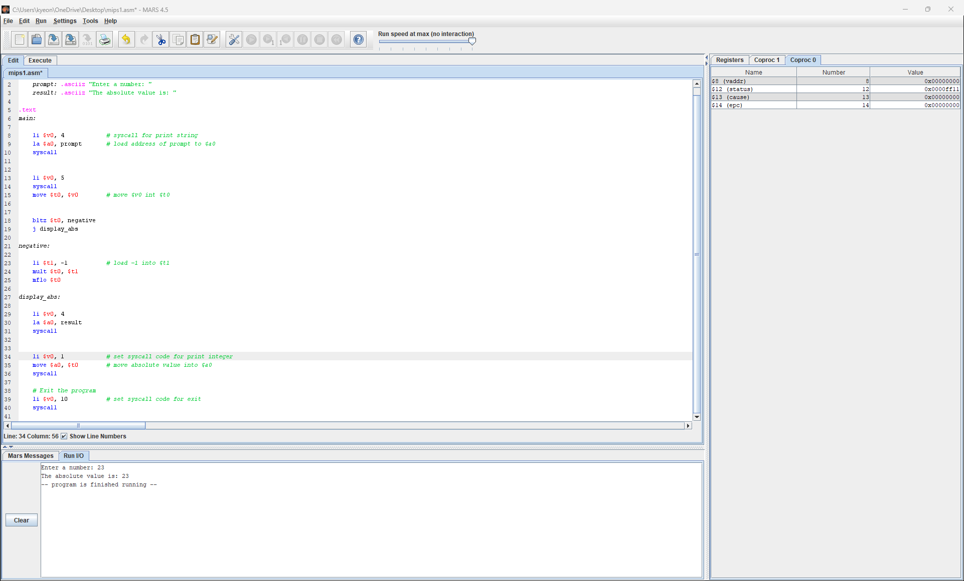

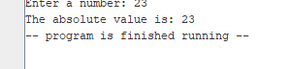
prompt: .asciiz "Enter a number: "
result: .asciiz "The absolute value is: "

.text
main:

li $v0, 4 # syscall for print string
la $a0, prompt # load address of prompt to $a0
syscall

li $v0, 5
syscall
move $t0, $v0 # move $v0 int $t0

bltz $t0, negative
j display_abs

negative:

li $t1, -1 # load -1 into $t1
mult $t0, $t1
mflo $t0

display_abs:

li $v0, 4
la $a0, result
syscall

li $v0, 1 # set syscall code for print integer
move $a0, $t0 # move absolute value into $a0
syscall

# Exit the program
li $v0, 10 # set syscall code for exit
syscall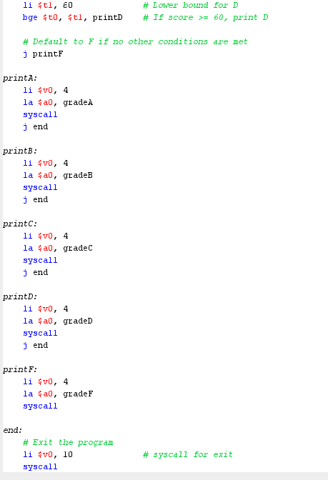

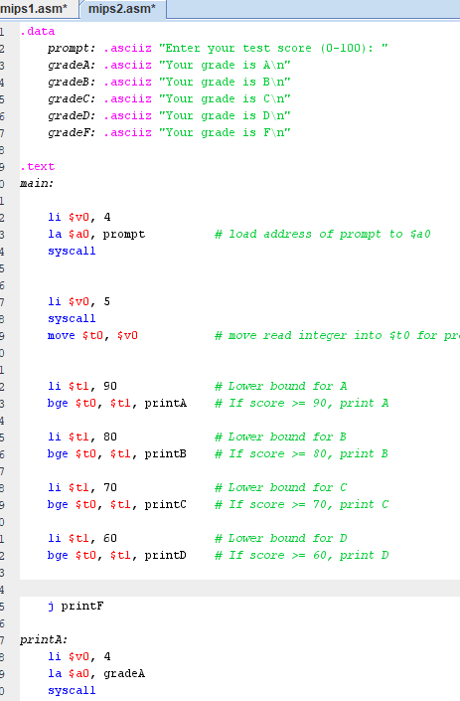

.data
prompt: .asciiz "Enter your test score (0-100): "
gradeA: .asciiz "Your grade is A\n"
gradeB: .asciiz "Your grade is B\n"
gradeC: .asciiz "Your grade is C\n"
gradeD: .asciiz "Your grade is D\n"
gradeF: .asciiz "Your grade is F\n"

.text
main:

li $v0, 4
la $a0, prompt # load address of prompt to $a0
syscall

li $v0, 5
syscall
move $t0, $v0 # move read integer into $t0 for processing

li $t1, 90 # Lower bound for A
bge $t0, $t1, printA # If score >= 90, print A

li $t1, 80 # Lower bound for B
bge $t0, $t1, printB # If score >= 80, print B

li $t1, 70 # Lower bound for C
bge $t0, $t1, printC # If score >= 70, print C

li $t1, 60 # Lower bound for D
bge $t0, $t1, printD # If score >= 60, print D

j printF

printA:
li $v0, 4
la $a0, gradeA
syscall
j end

printB:
li $v0, 4
la $a0, gradeB
syscall
j end

printC:
li $v0, 4
la $a0, gradeC
syscall
j end

printD:
li $v0, 4
la $a0, gradeD
syscall
j end

printF:
li $v0, 4
la $a0, gradeF
syscall

end:
# Exit the program
li $v0, 10 # syscall for exit
syscall

